2017-04-05

Bryan Greener

Chad Hirsch

Jason Gunderson

Workshop CH 10

10.22

a)

Area:

Min. 1st Qu. Median Mean 3rd Qu. Max.

2.00 16.00 26.00 28.29 34.00 70.00

IBI:

Min. 1st Qu. Median Mean 3rd Qu. Max.

29.00 55.00 71.00 65.94 82.00 91.00

b)

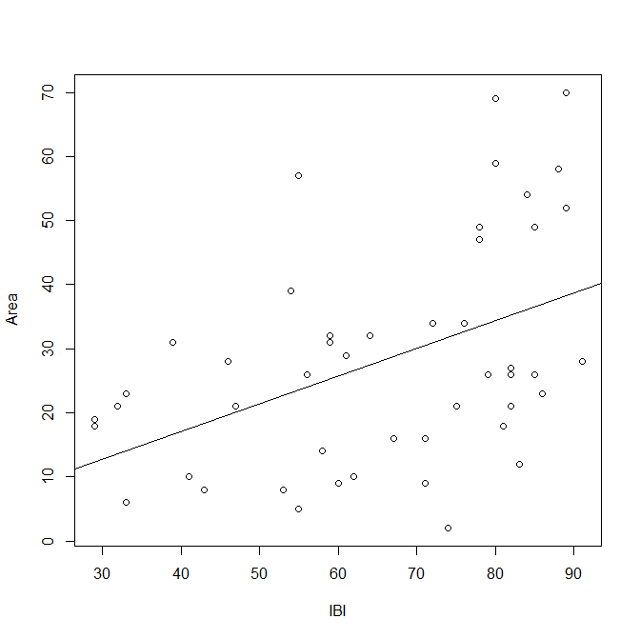

There seem to be some outliers around 50 IBI and at about 80-90 IBI where the Area is much larger than it should be based on the IBI level.

c)

Residuals:

Min 1Q Median 3Q Max

-29.769 -12.744 1.367 12.477 34.638

Coefficients:

Estimate Std. Error t value Pr(>|t|)

(Intercept) -0.2084 8.6510 -0.024 0.98088

IBI 0.4321 0.1265 3.415 0.00132 \*\*

---

Signif. codes: 0 ‘\*\*\*’ 0.001 ‘\*\*’ 0.01 ‘\*’ 0.05 ‘.’ 0.1 ‘ ’ 1

Residual standard error: 16.02 on 47 degrees of freedom

Multiple R-squared: 0.1988, Adjusted R-squared: 0.1818

F-statistic: 11.67 on 1 and 47 DF, p-value: 0.001322

d)

H0: beta1=0 Ha: beta1!=0

Since our p-value is less than 0.05 we reject null hypothesis.

e)

Analysis of Variance Table

Response: Area

Df Sum Sq Mean Sq F value Pr(>F)

IBI 1 2995 2995.03 11.665 0.001322 \*\*

Residuals 47 12067 256.74

---

Signif. codes: 0 ‘\*\*\*’ 0.001 ‘\*\*’ 0.01 ‘\*’ 0.05 ‘.’ 0.1 ‘ ’ 1

f)

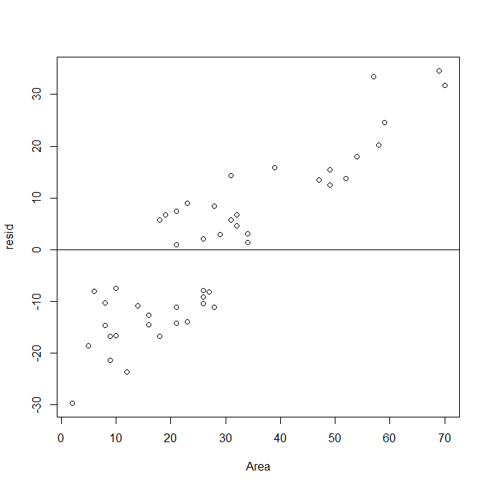

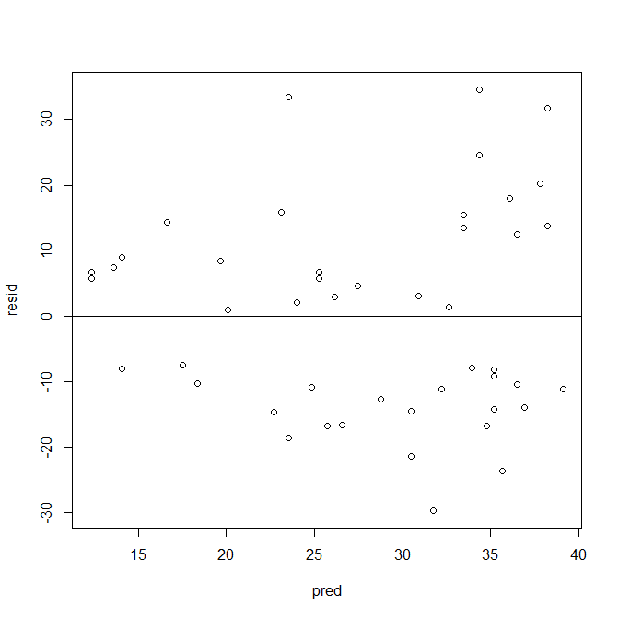

g)

No. Near the right side of the residuals the values get further and further from the line.

h)

Yes as they seem to fit the graphical data that we put earlier in this problem.

10.23

a)

Forested is right skewed.

IBI is left skewed.

b)

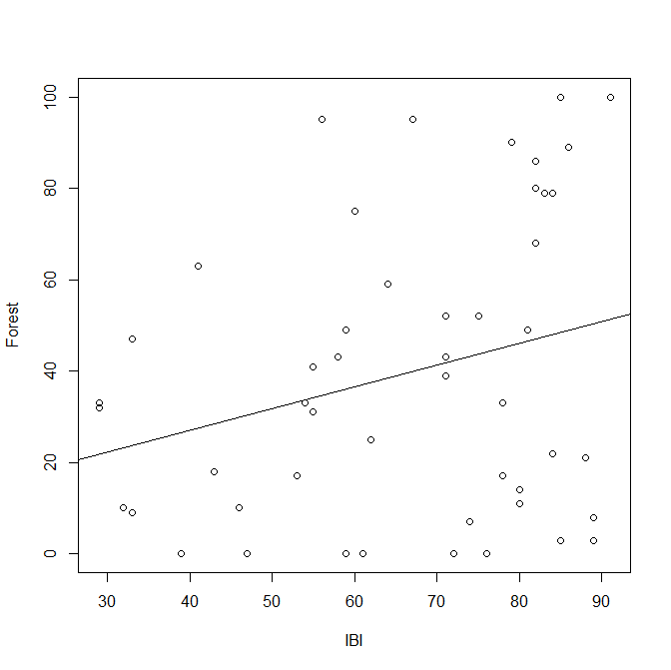

Weak positive association with more deviation in y.

c)

Residuals:

Min 1Q Median 3Q Max

-47.349 -28.120 -0.713 23.268 60.336

Coefficients:

Estimate Std. Error t value Pr(>|t|)

(Intercept) 8.0474 16.9197 0.476 0.6365

IBI 0.4753 0.2475 1.921 0.0608 .

---

Signif. codes: 0 ‘\*\*\*’ 0.001 ‘\*\*’ 0.01 ‘\*’ 0.05 ‘.’ 0.1 ‘ ’ 1

Residual standard error: 31.34 on 47 degrees of freedom

Multiple R-squared: 0.07278, Adjusted R-squared: 0.05305

F-statistic: 3.689 on 1 and 47 DF, p-value: 0.06084

H0: beta1=0 Ha: beta1!=0

e)

Analysis of Variance Table

Response: Forest

Df Sum Sq Mean Sq F value Pr(>F)

IBI 1 3623 3623.2 3.6893 0.06084 .

Residuals 47 46158 982.1

---

Signif. codes: 0 ‘\*\*\*’ 0.001 ‘\*\*’ 0.01 ‘\*’ 0.05 ‘.’ 0.1 ‘ ’ 1

f) residual plot has a curve

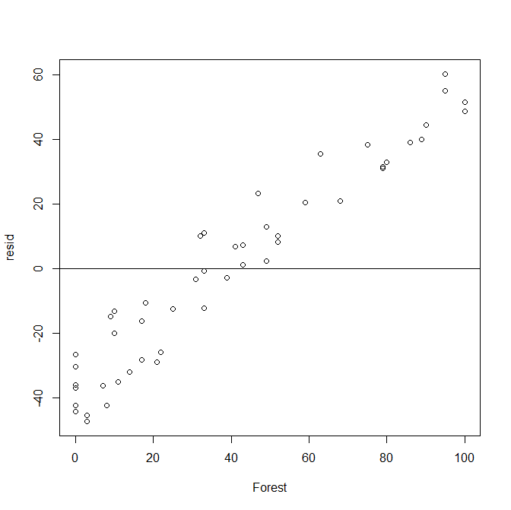

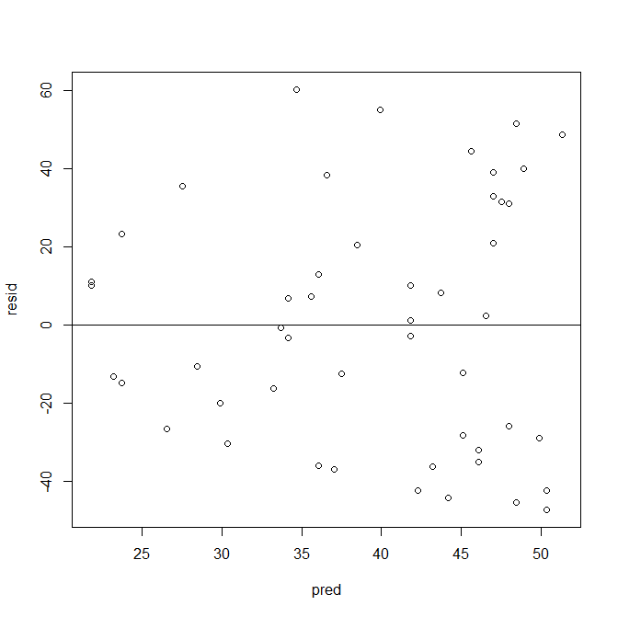

g) residuals are left skewed

10.24

I prefer the tests using IBI and Area over the tests using IBI and Forest as the effects of IBI on the area of the tree seem to be more closely related than the other tests from part 10.23.

10.26

a)

70.71053 90.35401

b)

45.8491 115.2154